Computer Shop System

Use-Case Specification: Delete comment

Version 1.0

Revision History

|  |  |  |  |
| --- | --- | --- | --- |
| **Date** | **Version** | **Description** | **Author** |
| 15/12/2019 | 1.0 | details | Hoang Trung Hieu |
|  |  |  |  |
|  |  |  |  |
|  |  |  |  |

Table of Contents

1. Use-Case Name 3

1.1 Brief Description 3

2. Flow of Events 3

2.1 Basic Flow 3

2.2 Alternative Flows 3

2.2.1 < First Alternative Flow > 3

2.2.2 < Second Alternative Flow > 3

3. Special Requirements 3

3.1 < First Special Requirement > 3

4. Preconditions 3

4.1 < Precondition One > 3

5. Postconditions 3

5.1 < Postcondition One > 3

6. Extension Points 3

6.1 <Name of Extension Point> 3

Use-Case Specification: Delete comment

# Use-Case Name

## Brief Description

This use case show steps of remove comment from database. The system allows computer store managers to delete a comment which being impolite.

# Flow of Events

## Basic Flow

First, Computer store managers click on delete comment button. The system will show on screen a notification to confirm that Computer Store managers want to delete whether or not. If click on “YES” button, the system will remove the comment from dataset. Otherwise, the delete action will not be executed.

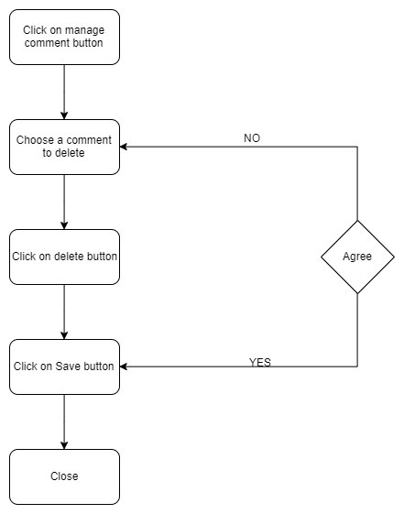

# Special Requirements

Computer store manager must know how to use management system.

# Preconditions

No preconditions

# Postconditions

The deleted comment must be removed from database

# Extension Points

None.